Name _______________________________Given Date: 5-2-18 Date Due: 5-16/5-17
Algebra Regents Review #9
Directions: Choose the best answer. Answer ALL questions. Show ALL work in column 2. If there is no mathematical work to be shown, write an explanation or definition to support your answer!
- Write the expression 5x + 4x²(2x + 7) − 6x² − 9x as a polynomial in standard form.
- Given that a > b, solve for x in terms of a and b: b(x − 3) ≥ ax + 7b
- Given that f(x) = 2x + 1, find g(x) if g(x) = 2[f(x)]²− 1
- A part of Jennifer’s work to solve the equation
2(6x² – 3) = 11x² – x is shown below.
Given: 2(6x² – 3) = 11x² – x
Step 1: 12x² – 6 = 11x² – x
Which property justifies her first step
- identity property of multiplication
- multiplication property of equality
- commutative property of multiplication
- distributive property of multiplication over subtraction
5.The cost of airing a commercial on television is modeled by the function C(n) = 110n + 900, where n is the number of times the commercial is aired. Based on this model, which statement is true?
- The commercial costs $0 to produce and $110 per airing up to $900.
- The commercial costs $110 to produce and $900 each time it is aired.
- The commercial costs $900 to produce and $110 each time it is aired.
- The commercial costs $1010 to produce and can air an unlimited number of times.
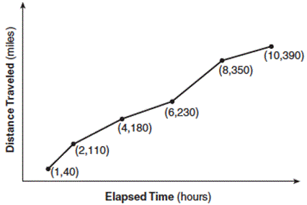
6.The Jamison family kept a log of the distance they traveled during a trip, as represented by the graph below.

During which interval was their average speed the greatest?
- the first hour to the second hour
- the second hour to the fourth hour
- the sixth hour to the eighth hour
- the eighth hour to the tenth hour
7. Which pair of equations could not be used to solve the following equations for x and y?
4x + 2y = 22
–2x + 2y = –8
- 4x + 2y = 22 3. 8x + 4y = 44
2x – 2y =8 –8x + 8y = –8
- 4x + 2y = 22 4. 12x + 6y = 66
–4x + 4y = –16 6x – 6y = 24

8. The table below represents the function F.
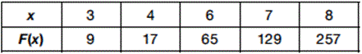The equation that represents this function is
- F(x) = 3^{x}
- F(x) = 3x
- F(x) = 2^{x} + 1
- F(x) = 2x + 3
9. The range of the function defined as y = 5^{x} is
- y < 0 3. y > 0
- y ≤ 0 4. y ≥ 0
10. When the function f(x) = x² is multiplied by the value a, where a > 1, the graph of the new function, g(x) = ax²
- opens upward and is wider
- opens upward and is narrower
- opens downward and is wider
- opens downward and is narrower
11. Which statement is not always true?
- The product of two irrational numbers is irrational.
- The product of two rational numbers is rational.
- The sum of two rational numbers is rational.
- The sum of a rational number and an irrational number is irrational.
12. Which expression is equivalent to x⁴ − 12x² + 36?
- (x² − 6)(x² − 6)
- (x² + 6)(x² + 6)
- (6 − x²)(6 + x²)
- (x² + 6)(x² − 6)
13. When factored completely, the expression p⁴ – 81 is equivalent to
- (p² + 9)(p² – 9)
- (p² – 9)(p² – 9)
- (p² + 9)(p + 3)(p – 3)
- (p + 3)(p – 3)(p + 3)(p – 3)
14. Which equation has the same solution as x² − 6x − 12 = 0?
- (x + 3)² = 21
- (x − 3)² = 21
- (x + 3)² = 3
- (x − 3)² = 3
15. What are the roots of the equation x² + 4x - 16 = 0?
- 3.
- 4.

- Write an equation that defines m(x) as a trinomial where m(x) = (3x − 1)(3 − x) + 4x² + 19. Solve for x when m(x) = 0. (4pts)

- 17. a. On the set of axes below, draw the graph of the equation  y = -x + 3.  b. Is the point (3, 2) a solution to the equation? Explain your answer based on the graph drawn. | 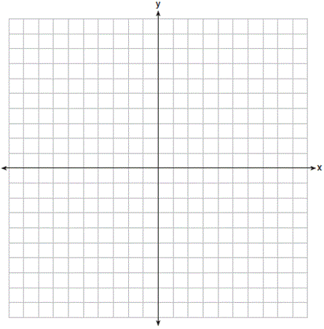
18) Jacob and Zachary go to the movie theater and purchase refreshments for their friends. Jacob spends a total of $18.25 on two bags of popcorn and three drinks. Zachary spends a total of $27.50 for four bags of popcorn and two drinks. (4 pts)
PART A:
Write a system of equations that can be used to find the price of one bag of popcorn and the price of one drink.

PART B:
Using these equations, determine and state the price of a bag of popcorn and the price of a drink, to the nearest cent.

